**PROJECT**

**3rd Increment Report**

**on**

**“CLASS SCHEDULER”**

**By**

**Sumanth Koushik Kalli**

**Alekhya Boyapati**

**Savya Pathuri**

**Importing Existing Services:**

The existing services in this 3rd increment are implemented using JavaScript, cascading style sheets (CSS), HTML language and PHP in making a better user interface. Also, we are trying to make part of the scheduling algorithm as SOAP web service. We have completed the installation of Database into our project. In the exercise of finding out the best scheduling algorithm, we have found that scheduling algorithms are best implemented using genetic algorithms.

**Detail Design of Services:**

In this web application, we have created a database which will be storing details of the courses such as Course ID and course name, Faculty name and Faculty ID, day of the class and timings of the class on each day. We have also got part of our scheduling algorithm which takes the input from the database and tells on which day a particular professor’s class is on.

**Sequence Diagram:**

The below diagram shows the sequence diagram of our application.

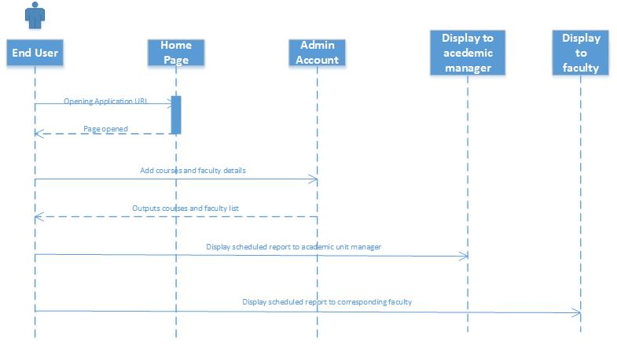

**System Architecture Diagram:**

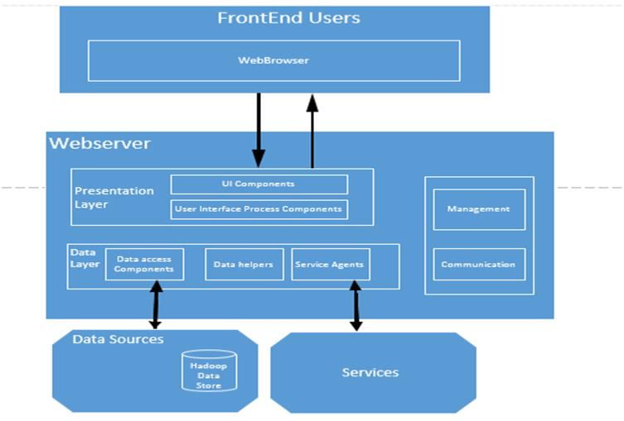

**Implementation**

**Implementation of services:** We created home screen for our project and also the chance to change the password for the users in our previous increments. In this increment we created the database and the related information like Course ID and course name, Faculty name and Faculty ID, day of the class and timings of the class on each day were stores in the database.

**Implementation of user interface:** The user interface was implemented using the HTML language and Cascading style sheets. The initial home screen is developed in this project for previous increments and now for this increment database was created with all the details required. Further modules will be added in upcoming increments.

**Report:** In our project “CLASS SCHEDULER” we have developed a part of front end and back end using HTML, JavaScript, CSS for web development. In this increment a database was created to store our details. Also, using C# and SOAP we have developed a web service that schedules on which particular day a particular professor’s class will be. All the classes were allocated into timetables.

We have entered all the data into the database that is collected from UMKC website regarding the courses offered in Fall 2013 Graduate Computer Science Degree and the names of the professors for that particular courses.

**Implementation Status Report**

**Work Completed:**

* **Description:** In this third increment, we completed the database creation with all the necessary details like Course ID and course name, Faculty name and Faculty ID, day of the class and timings of the class on each day. We have also allocated all the classes into timetables.
* **Responsibility:**

**Algorithm:** The logic for the algorithm has come out through everybody’s thought process and also the implementation of this logic is done by Sumanth, Alekhya and Savya.

**Database creation:** It has been done by Savya Pathuri.

**Front end user display:** This front end user display was done by Sumanth Koushik kalli and Alekhya Boyapati.

**Logic creation:** This was everybody active part in creation of logic for the algorithm.

**Documentation:** Documentation for the 3rd increment has been prepared by Alekhya

Boyapati, Sumanth Koushik Kalli.

* **Time Taken:** Individually, we have spent 60 hours each towards this increment.
* **Contributions:**

**Sumanth:** data analyzing, front end user display

**Alekhya:** logic building, documentation and front end user display.

**Savya:** Collecting data about professor and database creation.

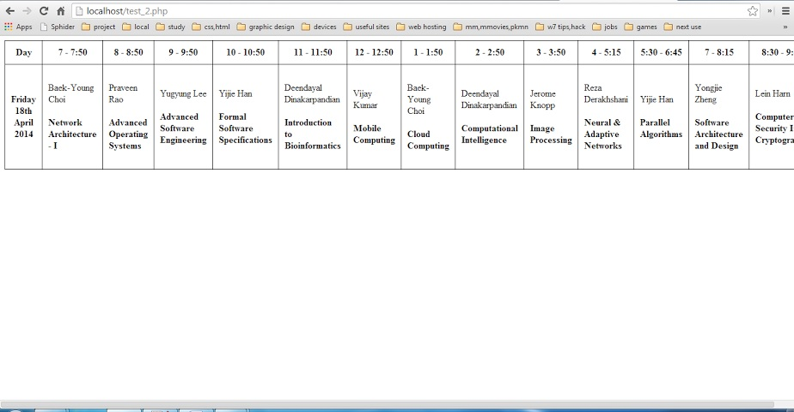

**Work to be completed:**

* **Description:** In this increment we are getting results only for one particular day. In further increments, we will move forward and complete the totaling classes scheduling for the entire week and also build schedule interface for display to faculty, adding send email to faculty feature to the Manager’s account. In this increment we created the logic for scheduling but not able to display it. We will make it for the next increment.
* **Responsibility:**

Completing this scheduling algorithm will be shared equally amongst the three team members. We all three will complete the entire project by next increment by displaying the logic behind the algorithm.

* **Time Taken:** We estimate that we require around 85 hours each for an increment.

**Issues/Concerns:**

As in the previous increment, we haven’t had any major technical issue. But, we are concerned about learning genetic algorithm and also in bringing out the logic behind the scheduling of classes.

**Deployment:**

**Scrum Do Link:** https://www.scrumdo.com/projects/project/increment-3/iteration/98301#

**Github Link:**